Python Programming

Experiment Report

Name DIO STANIA ADINATA
Student Number
Major Software Engineering
Class 2023

2022

Experiment 4

- Experimental Purpose
Experiment 2 aims to deepen the understanding of Python programming through the following objectives:
  - Understand how to create dictionaries from two lists, using elements from one list as keys and the other as values.
  - Performing basic set operations including union, intersection, adding elements, and deleting elements.
- Experiment Content
  - Objective1: Dictionary from Two Lists
    - Design thought
I plan to create a Python program that have two lists, lstA and lstB are provided as inputs, each containing four integers. Then I’m using the zip() function, after that I pair elements from both lists and convert the result into a dictionary, where elements from lstA become keys and elements from lstB become values. The dictionary is then printed.
    - Source Code
# Input two lists of four integers each
lstA = list(map(int, input("Enter four number (interger) for lstA (Use 'Space' to seperate the numbers): ").split()))
lstB = list(map(int, input("Enter four number (interger) for lstB (Use 'Space' to seperate the numbers): ").split()))

# Ensure both lists have exactly four elements if len(lstA) == 4 and len(lstB) == 4:
result_dict = dict(zip(lstA, lstB)) print("Dictionary:", result_dict)
else:
print("Please enter exactly four integers for each list.")

    - Experiment Result
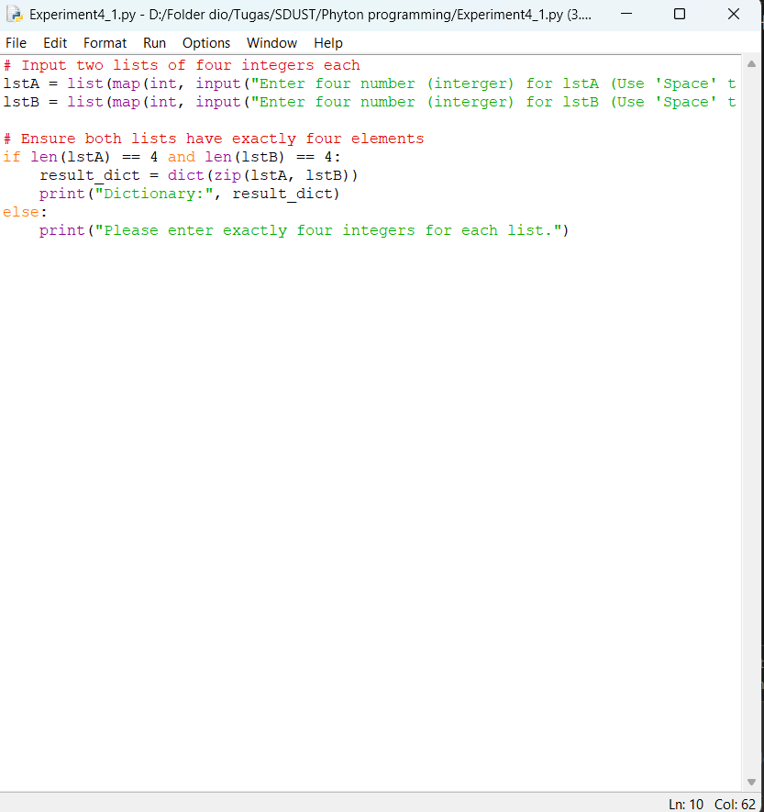
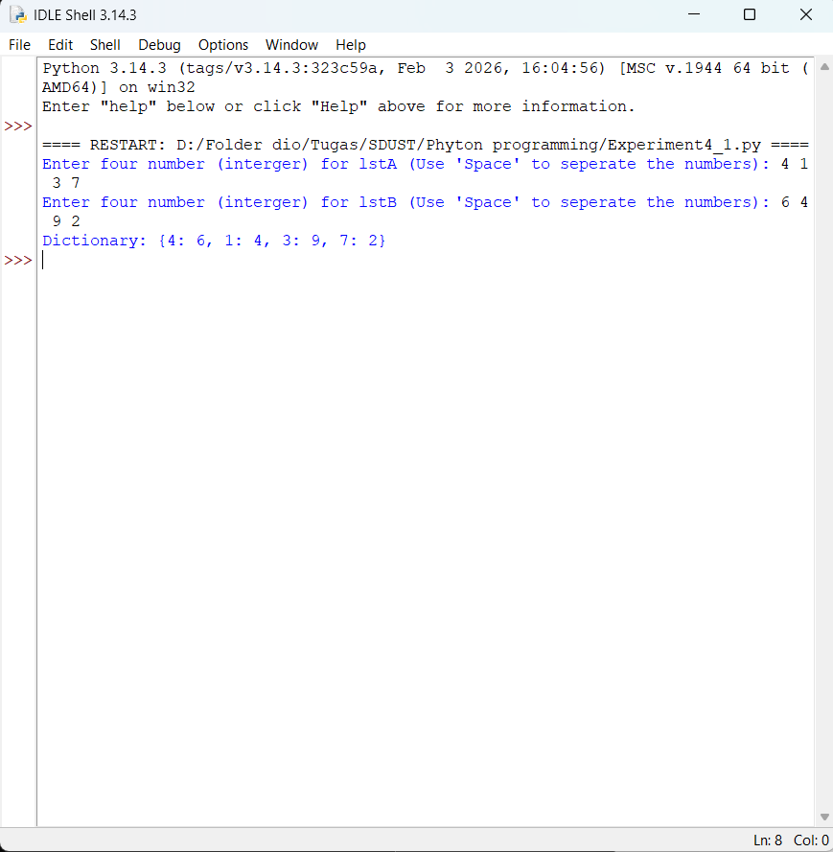

  - Objective2: Union and Intersection
    - Design thought
I plan to create a two set, set1 and set2 and they are assumed to be predefined. The union of set1 and set2 is obtained using the | operator or the union() method, and the result is assigned to set3. For the intersection, using the & operator or the intersection() method, and again assigned to set3.
    - Source Code
# set1 and set2 set1 = {1, 2, 3, 4}
set2 = {3, 4, 5, 6}

# Union
set3 = set1 | set2 # or set1.union(set2) print("Union (set3):", set3)

# Intersection
set3 = set1 & set2 # or set1.intersection(set2) print("Intersection (set3):", set3)
    - Experiment Result

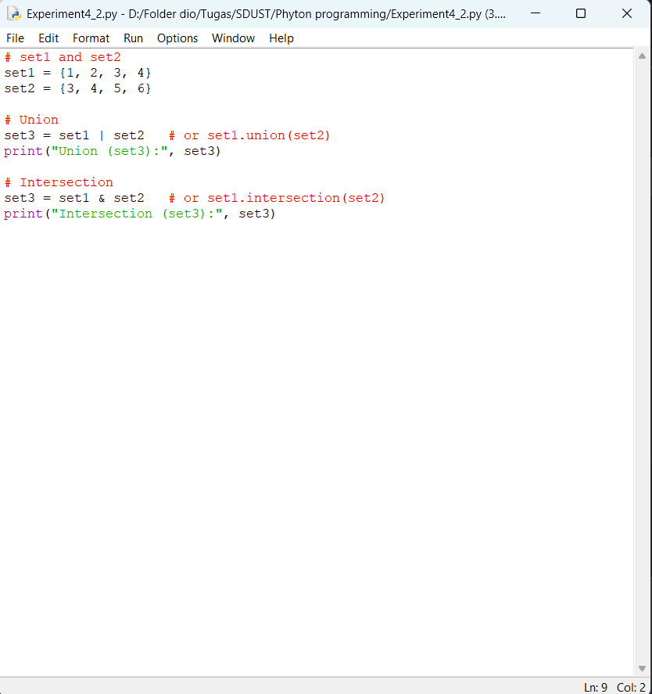
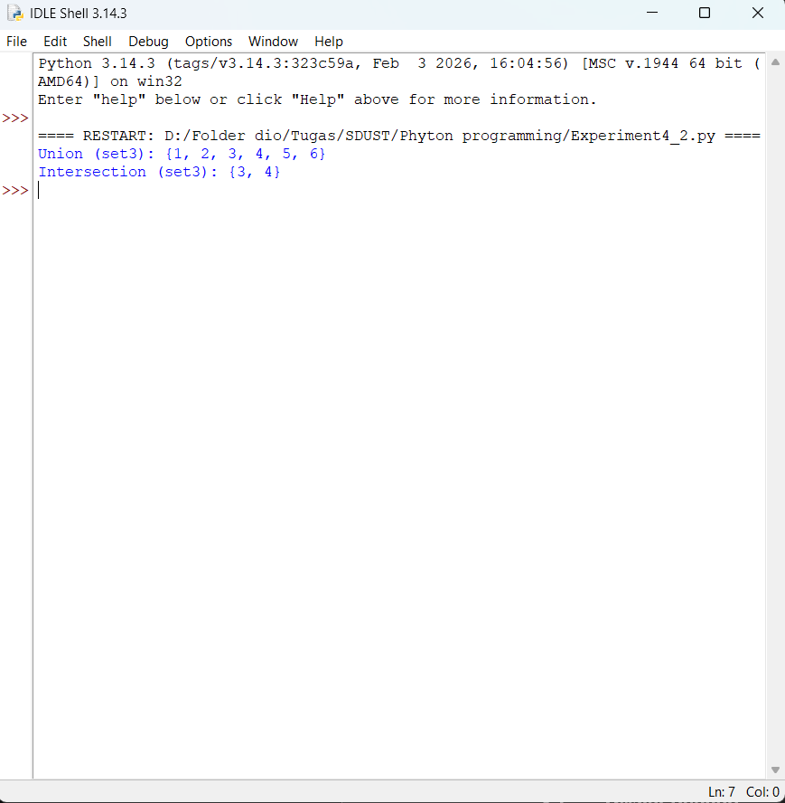

  - Objective3: Add, Delete, Print
    - Design thought
I plan to create a set of list with three elements: 10, 20, 30. The set is printed, then I add two new elements, 40 and 50 using the add() method. And the set is printed again. After that I remove elements 30 using the remove() method, and the set is printed again.
    - Source Code
numbers = []

#input
print("Please enter 20 numbers:") for i in range(20):
num = float(input(f"Enter number {i+1}: ")) numbers.append(num)

lowest = min(numbers) highest = max(numbers) total = sum(numbers)
average = total / len(numbers)

#output
print("\n--- Results ---") print("Lowest number:", lowest) print("Highest number:", highest) print("Total of numbers:", total) print("Average of numbers:", average)
    - Experiment Result

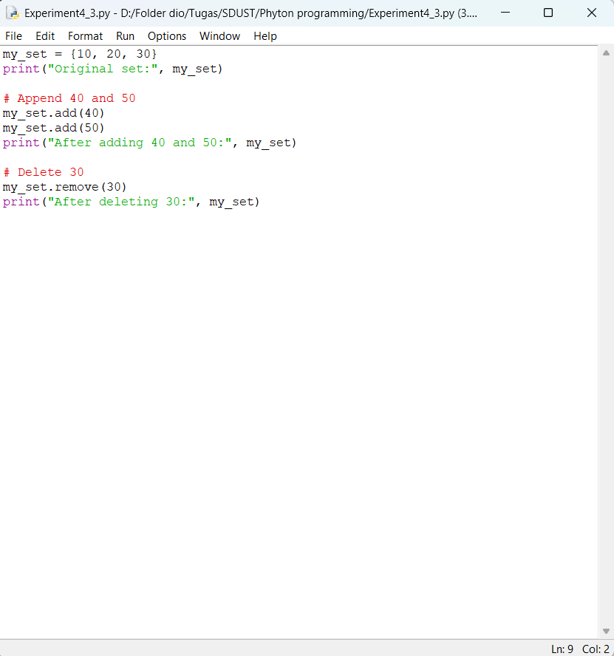
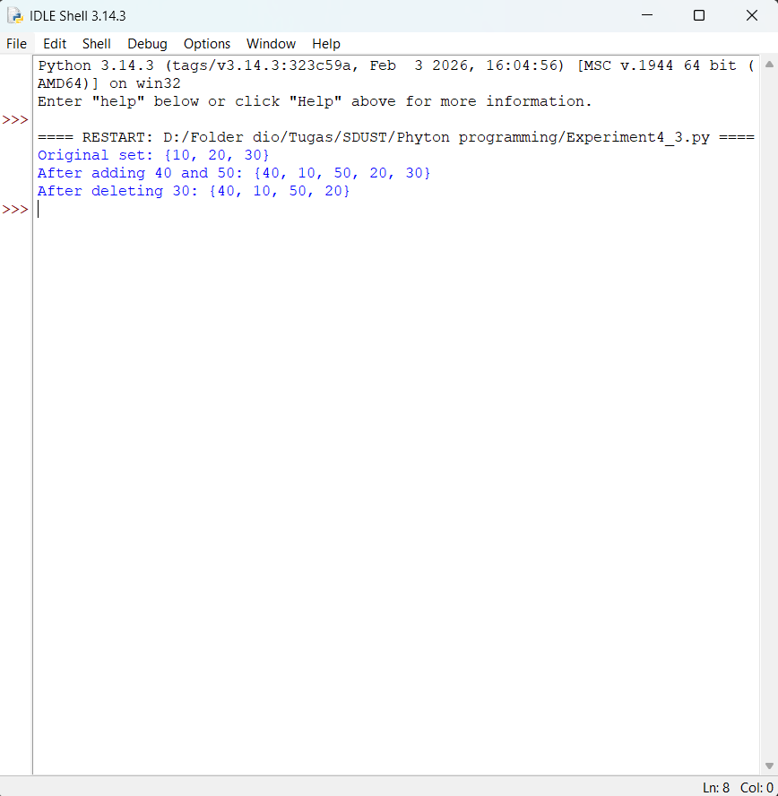

- Experiment Conclusion
What did you learn from the experiment?
From this experiment I learned several important concepts in Python programming. I learned how to work with dictionaries and sets in Python. In Python, I create two parallel lists for dictionary using the zip() which pairs each key with a corresponding value. For sets, I understood how to perform union and intersection operations to combine or find common elements between two sets. I also learned how to modify a set by adding new elements with the add() method and removing existing elements with the remove() method.

